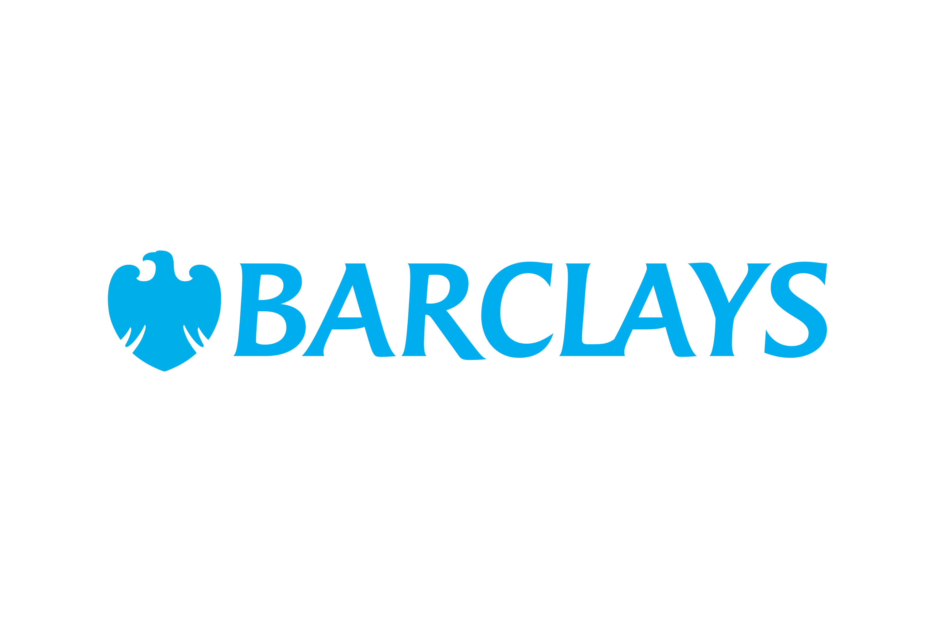
Barclays Community Sport Fund - £1,000 Access Grant

Closing date: 22 June 2025

We will not accept applications by email unless previously approved.
We encourage you to read the criteria thoroughly for the best chance of success.
There are additional demographic questions about you and your group in the application form.

Note: The Barclays Community Sport Fund is focused on supporting women and girls from areas of high deprivation (IMD 1-3). Please use these links below to check your organisations' postcode: England | Wales | Scotland | Northern Ireland

£1,000 Access Grant Questions

Tell us about your organisation and the community you serve, highlighting any issues or challenges. (200-word max)
Tell us about the sport activities you run for women and girls. (200-word max)
In a typical week, how many women and girls take part in your sport activities?
Tell us what you plan to do with this grant, demonstrating how you will you use this funding to support the delivery of sport activities to women and girls most at need. (200-word max)
Help us to understand why your activities are needed. Have you consulted the women and girls you serve and your wider community? What have they told you? (200-word max)

