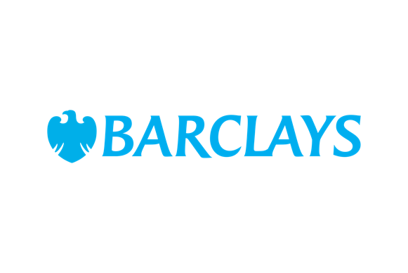
Barclays Community Sport Fund – Female Coaches for Girls Grant

Closing date: 22 June 2025

We will not accept applications by email unless previously approved.

We encourage you to read the criteria thoroughly for the best chance of success.
There are additional demographic questions about you and your group in the application form.

Female Coaches for Girls Grant Questions
Tell us about the sport activities you run for women and girls. (200-word max)
In a typical week, how many women and girls take part in your sport activities?
How will qualifying new female coaches support the delivery of your women and girls’ sport activities? (200-word max)​
Questions for each coach (max 2)
Age of your nominated coach
What is the ethnicity of your nominated coach?
Does your nominated coach have a disability?
Tell us about their current coaching experience, if any. (200-word max)
What is their connection to your organisation?
What makes them a great coach? OR Why do you think they will be a great coach? (200-word max)

