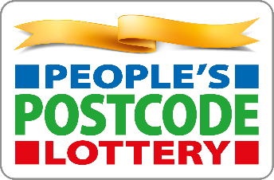
Community Grants Programme, supported by the players of Peoples Postcode Lottery
Reporting Requirements
If your group receives a grant, we’ll ask you to complete a short review form once your project or activities are finished, to tell us about how you used the grant and its impact. This helps us understand the difference the funding has made, share your achievements with funders and partners, and tell that story through our marketing and communications.
To make this simple, here’s what you’ll need to collect during your project:
Project delivery
- A short description of what you were able to do with the grant.
- A breakdown of what the money was spent on.
- Any major changes to how you spent the grant compared to your original plan.
- Any challenges you faced in delivering the project or during the application process.
Impact and outcomes
- How far you agree that the funding made a positive difference to your organisation.
- Whether the grant helped you run more activities or increase your capacity.
- The difference the grant made to your group, your participants, and your community.
- Whether the grant helped you secure additional funding from elsewhere.
- Numbers of participants reached, including:
  - How many people / participants engaged.
  - How many new participants you were able to involve.
Feedback and stories
- Any quotes or comments from participants, parents, or leaders that show the impact of your work.
- Photos of your project (if you’re happy for us and the funder to use them in reporting or communications).
Organisational reflection
- A short reflection (rating scale) on your organisation’s ability to achieve outcomes, adapt to challenges, and meet community needs.

