

Community Grants Programme, supported by Postcode Lottery players

Promotional Advice for grant recipients
Congratulations on being awarded a grant from the Community Grants Programme, supported by Postcode Lottery players, delivered in partnership with Sported. We think that’s something worth shouting about!
To make some noise, this pack contains logos and helpful advice and guidance on how to celebrate your grant.
Talking about this funding demonstrates to other potential donors and funders that you’re a trusted organisation and further promotes your work to your followers and local community.
You can do this across your marketing and social media, as outlined below. And why not use photos and videos to bring it to life?

Descriptions and Referencing
The award is from the Community Grants Programme, supported by Postcode Lottery players. When referencing Sported in connection with the funding, please use, ‘in partnership with’. For example:
“We are delighted to have been awarded a grant from the Community Grants Programme, supported by Postcode Lottery players and delivered in partnership with Sported.”
If you would like to include a short description of the Community Grants Programme to accompany your promotional activities, such as your website or social media, please use the following:
‘’The Community Grants Programme supports sport and physical activity community projects, thanks to funding raised by Postcode Lottery players. The programme delivers grants and support to community organisations (like ours) delivering sport and physical activity for wider social purpose.’
If you would like to include a short description about the Postcode Lottery, please use the following:
“Postcode Lottery players raise amazing amounts of money for charities. And so far, they’ve raised £1.7 billion for good causes.
“Funding raised by Postcode Lottery players was awarded to Sported to allow them to distribute funds directly to community groups. The incredible support from Postcode Lottery players is helping create opportunities for our next generation while building a strong and resilient society.”
If you would like to include a short description about Sported, please use the following:
“Sported is the UK’s largest grassroots sport charity, supporting over 5,000 groups and clubs across the UK to transform lives and strengthen communities. Through its free support and funding, it uses the power of sport to help over one million people each year and to make sure no-one is left on the sidelines.”

Postcode Lottery dual branded logos
Awards are made through one of the local Postcode Trusts integrated with the Postcode Lottery. Please acknowledge the support of players by using the relevant dual brand logo that corresponds to the Trust making your award. Never use the Postcode Lottery logo on its own.
For example, if your organisation is awarded funds from Postcode Trust you should use that Trust’s dual logo. Horizontal and vertical logos for each Trust are available here.
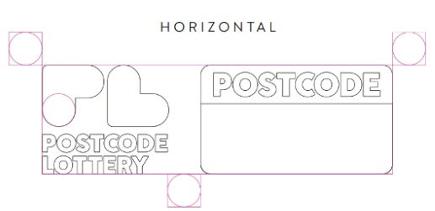 | 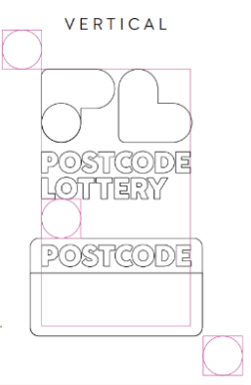

Sported logo
You may use Sported's logo on your website.
Black logo with blue tick, transparent background.
You can use this on a white or light background. Ensure there is space around the logo.
Ctrl + Click to download here Sported logo

Download


If you require our logo in another format, please email postcodelottery@sported.org.uk

Social Media
Here are some content ideas:
- Highlight what you’re using the grant for
- Share the impact of your activities
- Quotes about your sessions from young people
Don’t forget to tag us on social media – we love to see what you’ve been up to!
- Postcode Lottery UK Sported on Facebook
- @PostcodeLotteryUK @sporteduk on Instagram
- #PostcodeLottery #Sported

Press releases
Local newspaper, radio, television and websites are a brilliant way to promote your accomplishments and acknowledge your grant. Not only does it let people know about your success, but it also promotes your activity to a wider audience.
Please keep Sported informed of any press activities – including articles, interviews or press releases. Please also let us know if your project is nominated for, or wins, any awards. All press releases that reference Sported and/or Postcode Lottery must be sent to Sported for approval prior to being released. Please send to postcodelottery@sported.org.uk

Other channels and marketing materials
You could also shout about the grant on your:
- Website – e.g. adding the logo on the partners/supporters page of your website
- Newsletters
- Promotional materials – e.g. brochures, posters, annual reports, signage
V. 5/26

