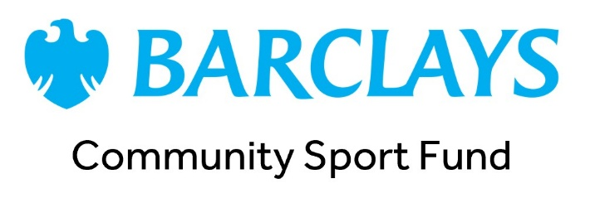

Barclays Community Sport Fund Female Coaches for Girls Grant

Grants Reporting Requirements
If your group receives a grant, we’ll ask you to complete a short review form once your funding activities are finished, to tell us about how you used the grant and its impact. This helps us understand the difference the funding has made, share your achievements with funders and partners, and tell that story through our marketing and communications.
The questions asked relate to the reach of the grant. By reach, we mean people exposed to the activities/support funded by the programme, and therefore with the opportunity to benefit from it. e.g. the coach, the women and girls who are coached, volunteers, etc.

To make this simple, here’s what you’ll need to collect during your funded activities:

Funding delivery
- A short description of what you were able to do with the grant.
- A breakdown of what the money was spent on.
- Any challenges you faced in delivering the funding or during the application process.
- General feedback on the grant process, including what worked well and what could be improved.

Reach and Participation
- The total number of people reached through the funded activities.
- The number of new participants as a result of the grant.
Simple attendance tracking and noting which participants are new will make this easier to report.
The total number of people exposed to the activities/support funded by the grant (Barclays Community Sport Fund Female Coaches for Girls Grant) and therefore with the opportunity to benefit from it.

